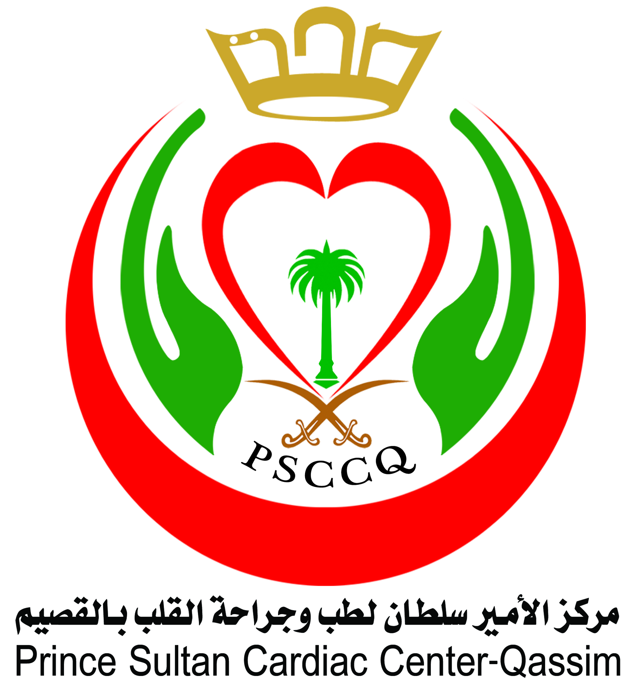

Prince Sultan Cardiac Center Qassim

EPIDEMIOLOGY & BIOSTATISTICS COURSE
27 – 28 February 2013G (17 – 18 Rabi Al Thani 1434H)

Day 1 - 27 February 2013G (17 Rabi Al Thani 1434H)
Prof. Mostafa Abolfotouh - Community Health Specialist NGH Riyadh
TIME | TOPIC
0800 – 0830 | REGISTRATION
0830 – 0930 | - Principles of Epidemiology
0930 – 1130 | - Natural History of Disease  - Measurements of Mortality  - Measures of Morbidity
1130 – 1300 | - Health Indices
1300 – 1400 | LUNCH BREAK + PRAYER
1400 – 1500 | - Research Methodology
1500 – 1600 | - Descriptive Epidemiology  - Descriptive Studies  - Analytic Studies
1600 – 1700 | - Hypothesis Generation, Causation  - Experimental Studies
1700 – 1800 | - Method of data Collection  - Screening & Validity and reliability of a data collection tool
Day 2 - 28 February 2013G (18 Rabi Al Thani 1434H)
Prof. Mostafa Abolfotouh - Community Health Specialist NGH Riyadh
0830 – 0930 | - Biostatistics  - Measures of central tendency  - Measures of dispersion
0930 – 1130 | - Normal Distribution Curve  - Measures of Correlation  - Types of variables-population & Samples
1130 – 1300 | - Population & Sampling Technique  - Basic Concepts in presentation of data  - Tabular and graphical Presentation
1300 – 1400 | LUNCH BREAK + PRAYER
1400 – 1500 | - Procedures for hypothesis Testing  - Hypothesis Testing Concepts
1500 – 1600 | - Meaning and use of reliability and significance of proportions and frequencies
1600 – 1700 | - Meaning & Use of Reliability and significance of arithmetic means
1700 – 1800 | - Meaning and use of non-paramedic tests of significance

